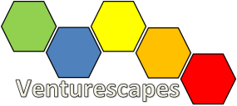
Tonight’s Mission: Start by gaining empathy. Get to know the needs of your users, the residents and “elders of Mt. Lebanon”.
The Problem: How will you engage, teach, and celebrate the history of Mt. Lebanon with its residents?

3 Capture Findings (3 min)

Needs (use verbs!)

Insights (New learnings about your user’s feelings/worldview to leverage your design)
2 Dig Deeper (2-4 min)
Notes from your second interview
1 Interview (2-4 min)
Notes from your first interview

